

**Spring 2020 Nominated Officer Questionnaire**

**INSTRUCTIONS**

Please attach your **current résumé** and **Spring 2020 schedule** (class, work, other extracurricular activities).

This questionnaire is due **no later than** **SUNDAY, November 24th at 11:59 PM.** Please send this document and all supplemental materials to [president.apousc@gmail.com](mailto:president.apousc@gmail.com) and cc webmaster.apousc@gmail.com.

*Election Day:* Candidates for President and Pledgemaster will have three minutes to give their speeches. Candidates for all other positions will have two minutes.

You may present **one slide** **per position** you run for at the time of your speech. If you are running all or nothing for a co position, you may share a speech with your running mate and have **up to** **two slides**. If you are not running all or nothing, you must have a separate speech and slide. Slides are due by **SUNDAY November 24th at 11:59 PM** to [president.apousc@gmail.com](mailto:president.apousc@gmail.com). You will not be allowed to pass out additional materials or papers during your speech.

**PART I: GENERAL INFORMATION**

Name: Mim Buranasiri

Year: Junior

Major: Global Health/ Minor: Consumer behavior, Social entrepreneurship

Pledge Class (Year): Alpha Nu Fall 2018

Have you finished requirements?: Yes

**Please mark which elected position(s) you are running for with an X:**

[ ]  President

[  ]  Pledgemaster

[  ]  VP of Service

[  ]  Co-VP of Membership

[  ]  VP of Fellowship

[  ]  Co-VP of Finance

[X]  VP of Communications

[  ]  IC Chair

Name of person you are running with (leave blank if no running partners):

Are you running all or nothing (leave blank if not applicable)?:

**PART II: SHORT ANSWER QUESTIONS**

1. **Why do you want the position(s) you are running for?**

I clearly remember my first GBM because I went in with the expectation that it would be very formal, but I was happily surprised when the GBM theme was “funny photos of actives”, and each slide was a mix of serious and fun with random photos of actives wedged in between important announcements. Over the past three semesters, I’ve learned that the APO community truly embodies USC’s “work hard, play hard” culture. Everyone I’ve met have not only been passionate and kind, but also funny and candid- a trait reflected in all the GBMs I’ve been to. As a new member over a year ago, I genuinely felt that the fun themes made me more comfortable around new people and genuinely brightened my Mondays. I want to be the VP of Communication because I believe the position enables APO’s fun and playful spirit to be translated to new members through the creative slides and emails. I believe that the position is not only responsible for recording minutes and creating slides, but also for integrating the chapter and strengthening the community. Essentially, I want to be the VP of Communication because I want to help foster APO’s fun energy and give back to the organization by using creative communication strategies to bridge the gaps between actives, associates, and new members.

1. **What is your vision for APO and what are your goals for the position(s)?**

As VP of Communications, my vision is for APO to be more integrated both internally and externally. Within APO, my main goal is to send out weekly emails that not only include EBM/GBM minutes, but also highlights of the week, brother bears, important announcements, “hot corner”, “myrtle hotseat” (read Q.3) etc.. I believe that adding fun elements of APO to the emails will encourage interaction among all members, particularly new members and associates. The fun elements would help new members feel more comfortable and involved in the organization as they can contribute to “hot corner” and try to identify myrtle by reading “myrtle hotseat”. On the other hand, associates could be quickly updated on important announcements and weekly highlights without having to read through all the EBM/GBM minutes.

As a chapter, we are very good at partnering with off-campus service organizations, but we rarely work with on-campus service organizations. This semester I was involved in USG’s Student Service Assembly (SSA) and realized that APO is relatively closed off to other service organizations. If on-campus service organizations want to collaborate with us their only option is to send an email, which is often intimidating. Thus, my external goal is to create channels of communication that would enable other on-campus service organizations to contact us easily. Additionally, I would work with the VP of Service to reach out to other on-campus service organizations.

1. **What new ideas can you bring to the position and organization as a whole? Please provide examples.**

**Internal Communication**

In order to strengthen APO’s internal communication, I plan to add other sections to the current weekly emails (the emails with the EBM/GBM minutes, slides, and secret word submission). Each weekly email will consist of ~five sections that would differ each week (in addition to the minutes/slides). The possible sections are…

|  |  |
| --- | --- |
| 1. **Important announcements**  * Important announcements would be at the top of the email and would remind members of upcoming deadlines, inform them about cancelled events, etc. * This section would be useful for actives/associates who couldn’t make it to GBM as they can be quickly updated on the important announcements. * This would also help other ex-comm members as they won’t have to spend as much time reminding members of certain deadlines/ posting on the Facebook group. |  |
| 1. **Upcoming events**  * A small calendar of upcoming events would be helpful for weeks with new and exciting events. Members who couldn’t make it to GBM/EBM would be made aware of new events without having to visit the APO website. |  |
| 1. **Highlights of the week**  * A couple of photos from the week to help members feel more involved/ be kept updated. |  |
| 1. **Important links**  * Important links (e.g. assassins sign-up, retreat sign-up, payment program form, membership form etc.) will be included in the email (when relevant). * Hopefully, this would push members to quickly complete the form, which would help other ex-comm members meet deadlines. |  |
| 1. **Brother bears of the week**  * Recognizing the brother bears of the week and acknowledging their LFS-ness. ☺ |  |
| 1. **Myrtle hot seat**  * Occasionally, Myrtle would be asked a fun question and all members would be able to see his/her response. This would allow actives/associates to be more involved in guessing Myrtle ‘s identity and would build up the suspense among all members before Myrtle is revealed at initiation. |  |
| 1. **Alumni/ ex-comm spotlight**  * Alumni and ex-comm spotlights to help new members get to know both their ex-comm and those who have graduated from USC and thus feel more integrated into the chapter. |  |
| 1. **Hot Corner**  * I would bring back “Hot Corner” but instead of just having ex-comm vote for new members, I would make it so that for some weeks it would be new members voting about actives and vice versa. The section would help encourage interaction between new members and actives. |  |

*Examples of what the email would look like on desktop and mobile are below.*

**External Communication**

1. **Channel for collaboration with other on-campus service organizations**

In order to make it easier for other on-campus service organizations to collaborate with APO, I plan to work with webmaster to create a page that outlines what APO’s service activities entail and opportunities for collaboration along with a google form for inquiries. Furthermore, I plan to use social media as a platform for interaction with other organizations by creating an Instagram story highlight and/or post that also outlines opportunities for collaboration with a link to the google form and the option to DM. The aim of the channels is to make APO more approachable as an organization and streamline the collaboration inquiry process. As mentioned earlier, I also plan to work with the VP of Service and reach out and form a good relationship with other service organizations. I plan on sending out a monthly newsletter that highlights our events and possible collaboration opportunities to other on-campus service organizations.

1. **What relevant experience, if any, have you had working in committees or other organizations for the position(s) you are running for? Please be specific.**

My experience as Historian this semester has given me an insight into how ex-comm operates as well as the communication branch of APO. I believe that I have developed both creative and time management skills from my position as Historian, which would support my role as VP of Communications. Moreover, this past summer I was a marketing intern for Jasberry (a small social enterprise and B Corp in Thailand). As the marketing intern, I drafted promotional Instagram captions and created a social media calendar to ensure that the posts were consistent. I believe my experience using social media in the corporate world has equipped me with the skills required to run APO’s social media pages. Lastly, my experience in SSA this semester has given me an understanding on how other on-campus service organizations work and the types of collaborations that already exist, which would helped me work with the VP of Service more efficiently to reach out to other service organizations.

1. **What other time commitments will you have next semester (i.e. other student organizations, work, research, etc.)? How do you plan to balance APO executive board duties with those commitments?**

My schedule for next semester isn’t fixed yet, but I plan to take 18 units and might be doing HP research. Currently, I do not have any commitments with other student organizations and would be able to devote a lot of time to the excomm position.

*Examples of what the weekly emails would look like are on the next two pages.*

**Examples of possible emails:**

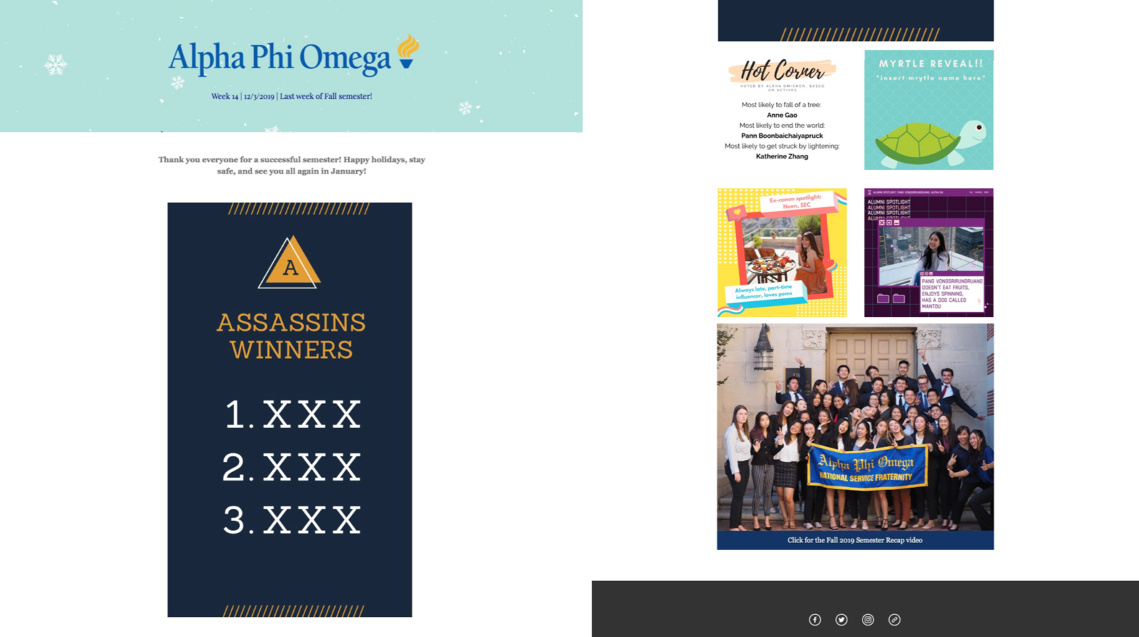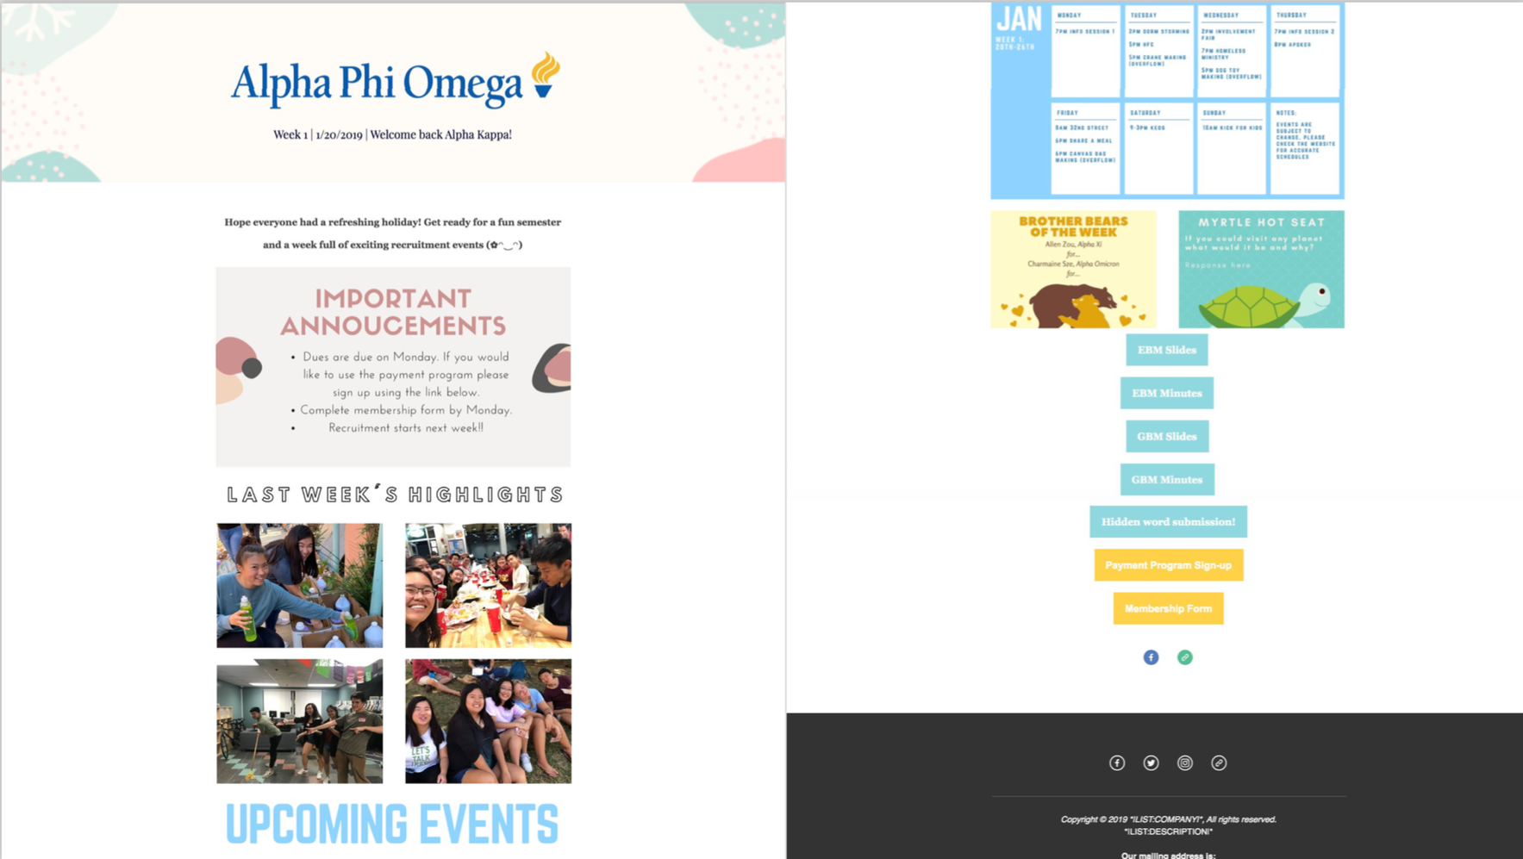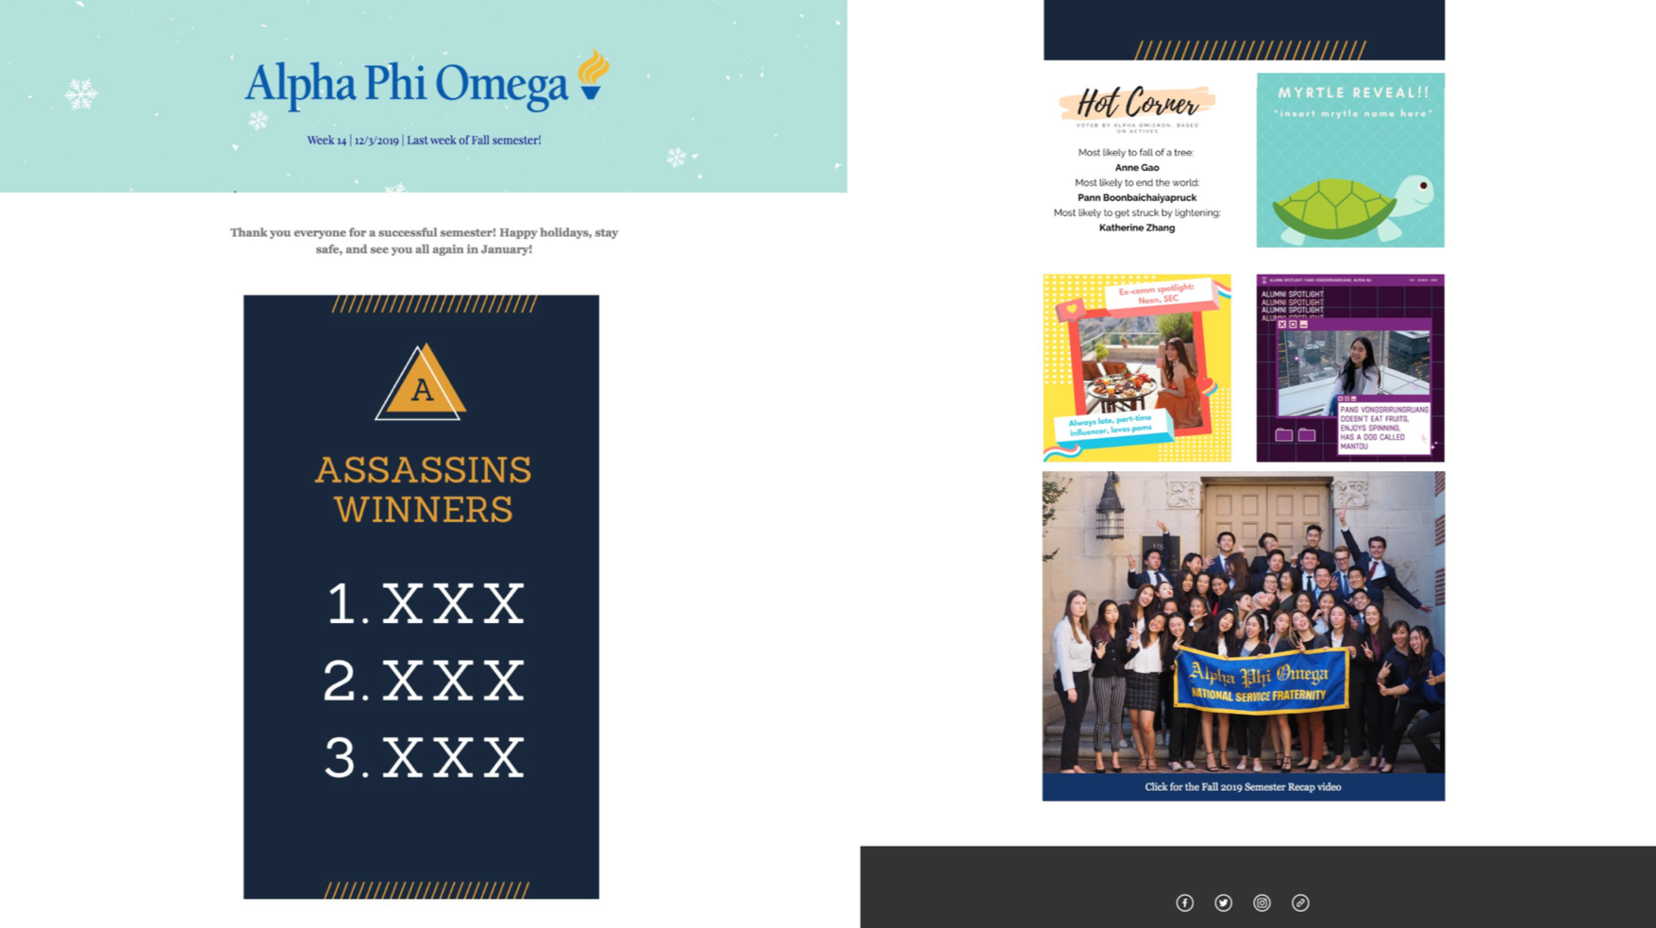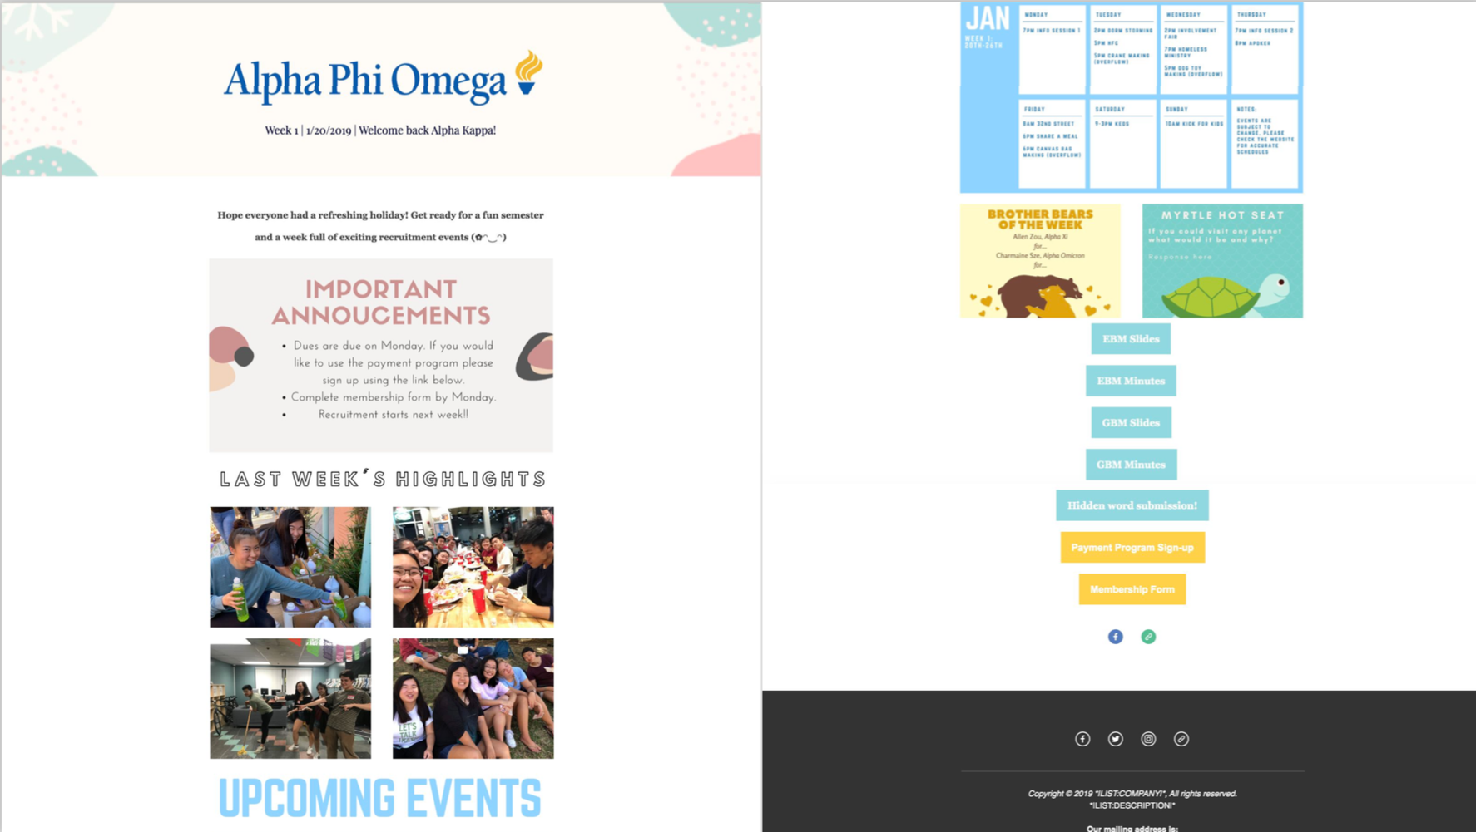

**Examples of mobile versions of the emails:**

